Download and install GitHub Desktop

what is GitHub Desktop
# Source: AI Source: Provided by: [Data Path: Persons Table -> ID Column: 1, Name_En Column: Motasem Essam] -> From: [Chatgpt (GPT‑5 Mini)] on [2/17/2026]
GitHub Desktop is a free graphical app that lets you use Git and manage repositories from GitHub without using the command line.
It’s designed to be simple and beginner-friendly.

What GitHub Desktop does
# Source: AI Source: Provided by: [Data Path: Persons Table -> ID Column: 1, Name_En Column: Motasem Essam] -> From: [Chatgpt (GPT‑5 Mini)] on [2/17/2026]
With GitHub Desktop you can:
- Clone repositories from GitHub
- Create new repositories
- Track file changes visually
- Commit with a message
- Push / Pull to sync with GitHub
- Create and switch branches
- Resolve merge conflicts with a visual tool
- View commit history
All using buttons and menus (no typing commands).

Who makes it
# Source: AI Source: Provided by: [Data Path: Persons Table -> ID Column: 1, Name_En Column: Motasem Essam] -> From: [Chatgpt (GPT‑5 Mini)] on [2/17/2026]
GitHub Desktop is developed by GitHub, which is owned by Microsoft.

Example workflow
# Source: AI Source: Provided by: [Data Path: Persons Table -> ID Column: 1, Name_En Column: Motasem Essam] -> From: [Chatgpt (GPT‑5 Mini)] on [2/17/2026]
Typical steps in GitHub Desktop:
- Open repository
- Edit files in your editor
- See changes in GitHub Desktop
- Write commit message → Commit
- Click Push origin to upload to GitHub

GitHub Desktop vs Git Bash
# Source: AI Source: Provided by: [Data Path: Persons Table -> ID Column: 1, Name_En Column: Motasem Essam] -> From: [Chatgpt (GPT‑5 Mini)] on [2/17/2026]
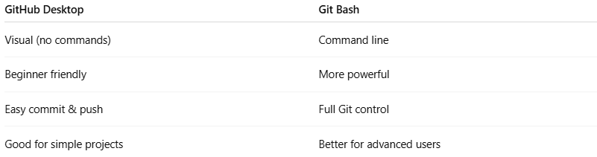
GitHub Desktop | Git Bash
Visual (no commands) | Command line
Beginner friendly | More powerful
Easy commit & push | Full Git control
Good for simple projects | Better for advanced users

Download GitHub Desktop
# Source: ScreenShots Source: Provided by: [Persons Table -> ID Column: 1, Name_En Column: Motasem Essam] -> Tool: [Lightshot Program] -> From [Site: Google Search: All: GitHub Desktop] on [2/17/2026]
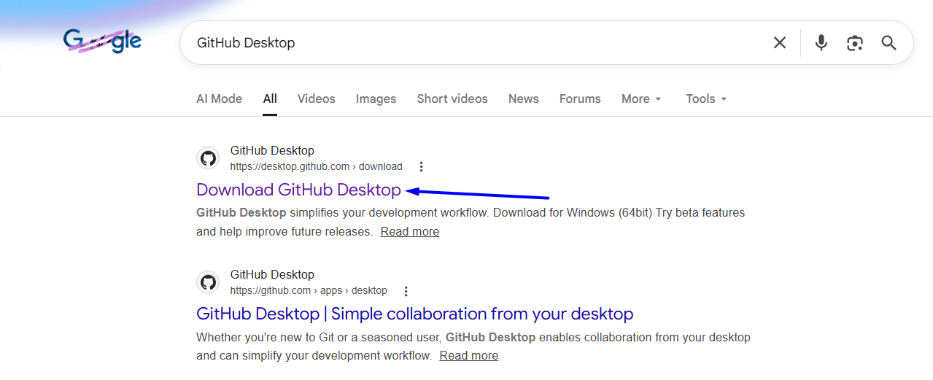
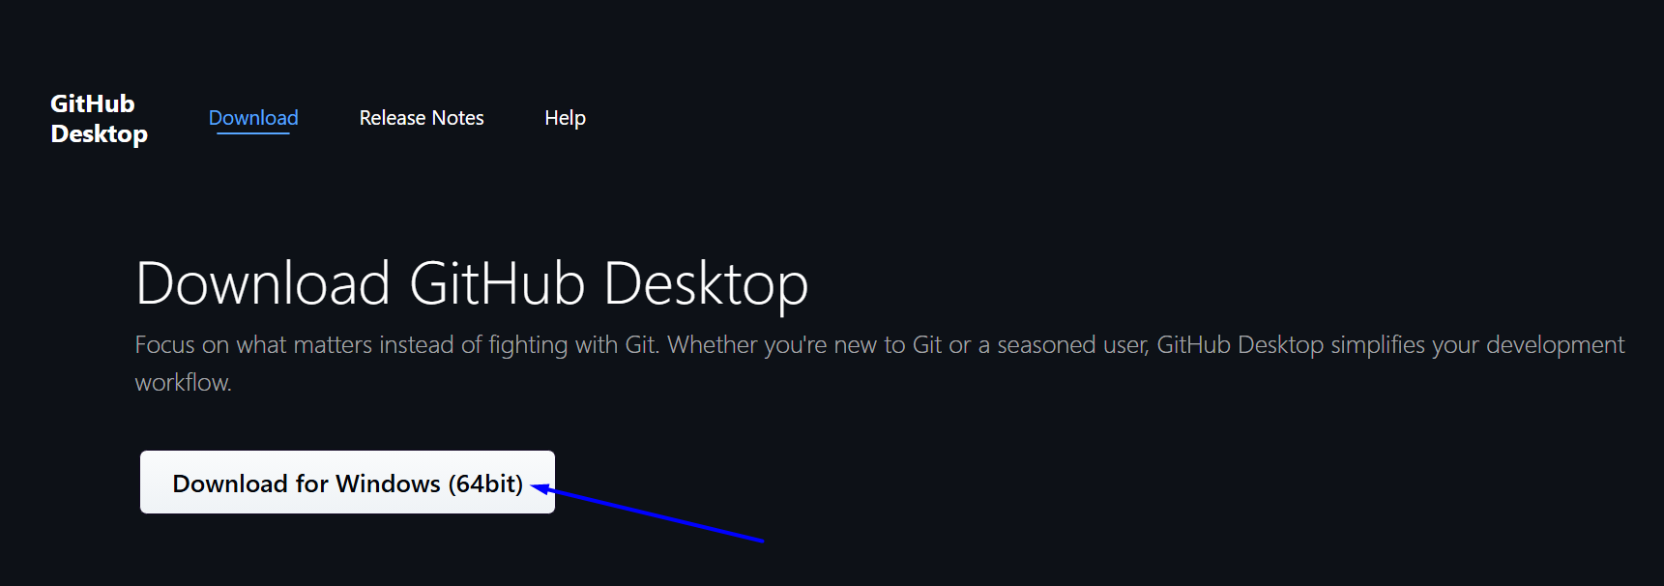
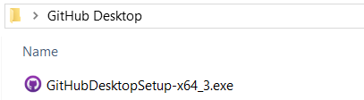

Install GitHub Desktop
# Source: ScreenShots Source: Provided by: [Persons Table -> ID Column: 1, Name_En Column: Motasem Essam] -> Tool: [Lightshot Program] -> From [Windows] on [2/17/2026]
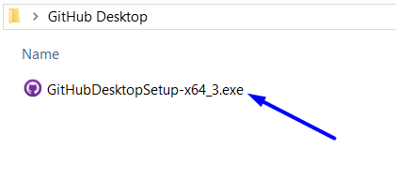
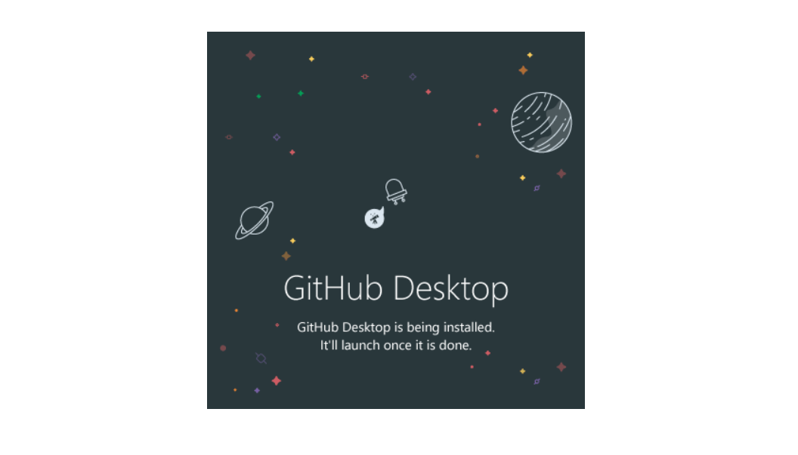

Run GitHub Desktop
# Source: ScreenShots Source: Provided by: [Persons Table -> ID Column: 1, Name_En Column: Motasem Essam] -> Tool: [Lightshot Program] -> From [Windows] on [2/17/2026]
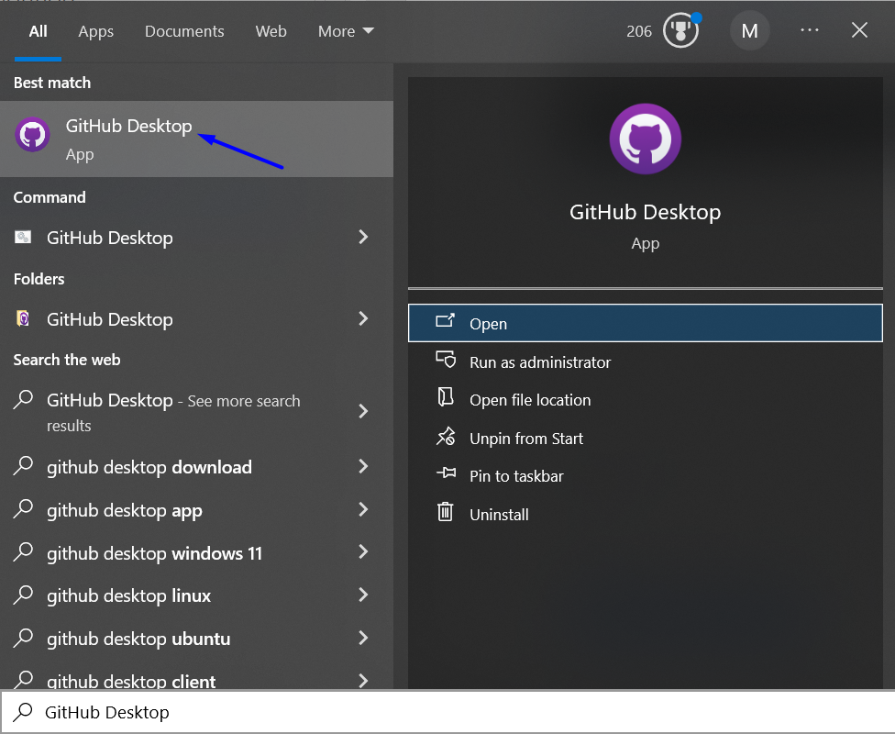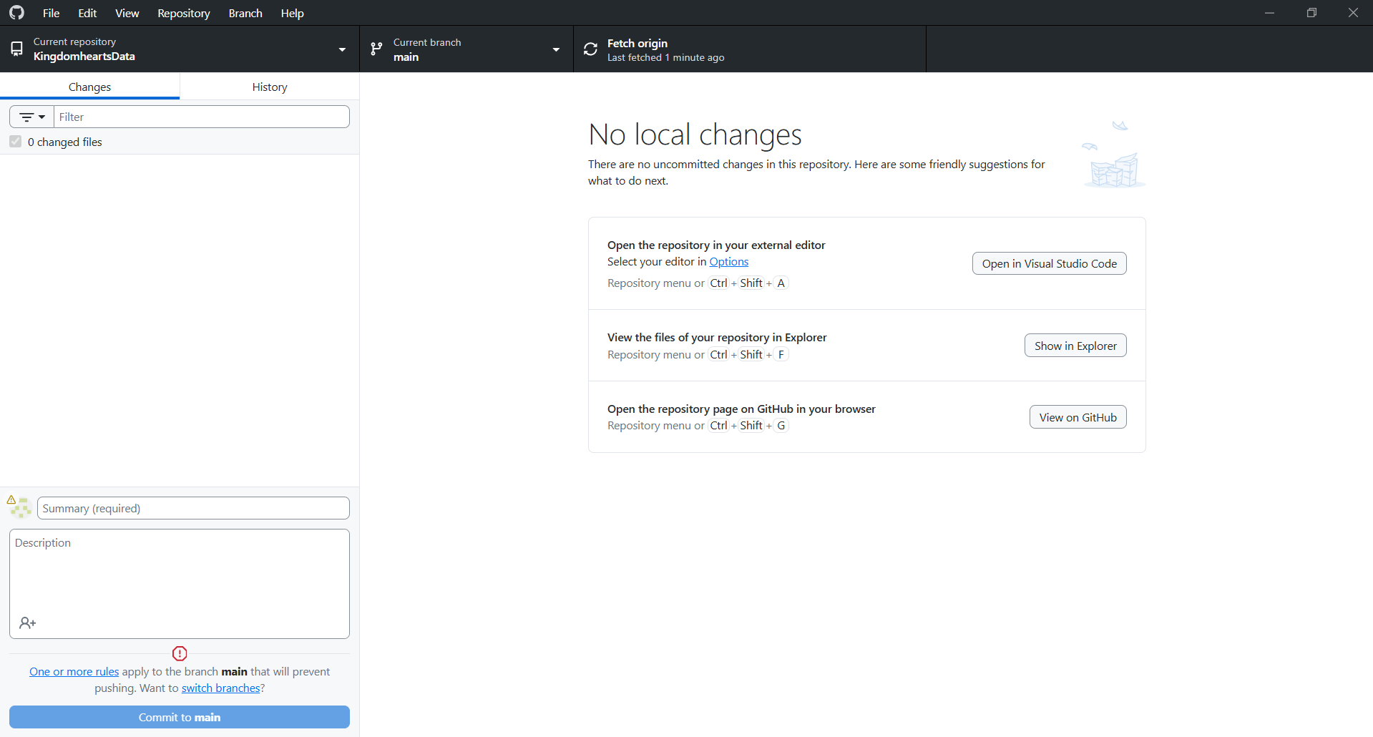

New repository
# Source: ScreenShots Source: Provided by: [Persons Table -> ID Column: 1, Name_En Column: Motasem Essam] -> Tool: [Lightshot Program] -> From [Windows] on [2/17/2026]
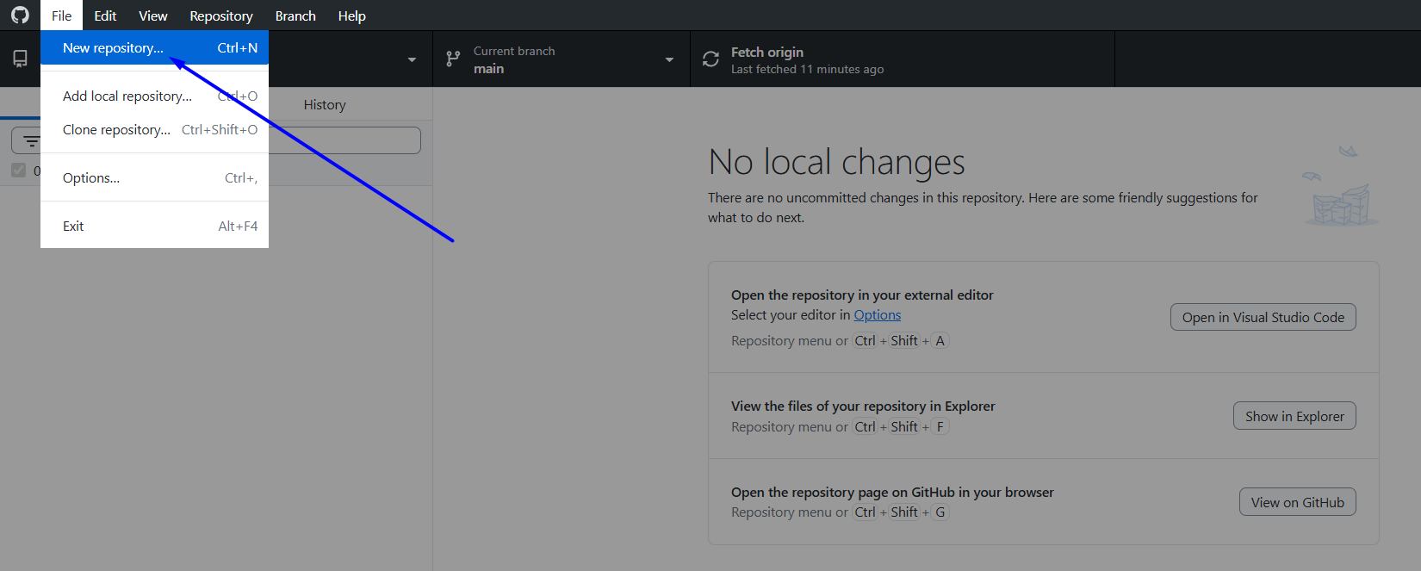
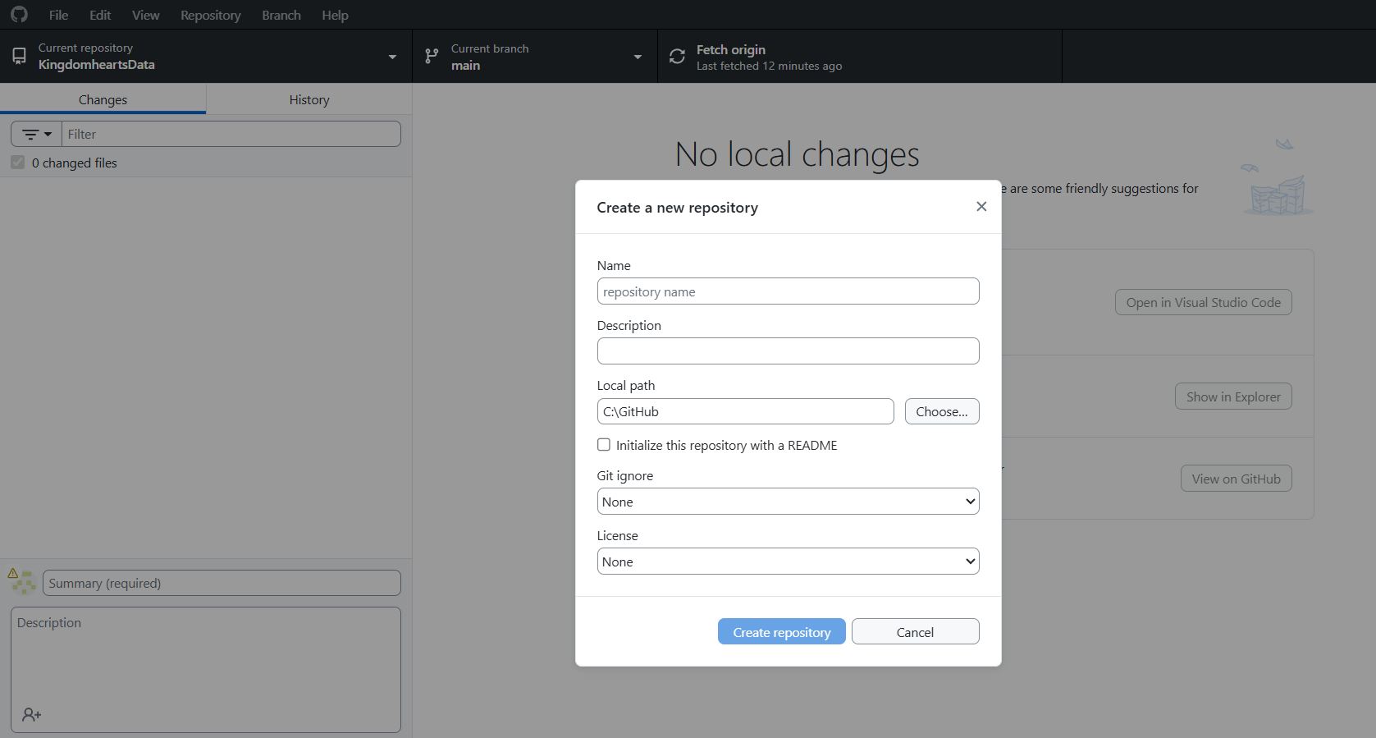
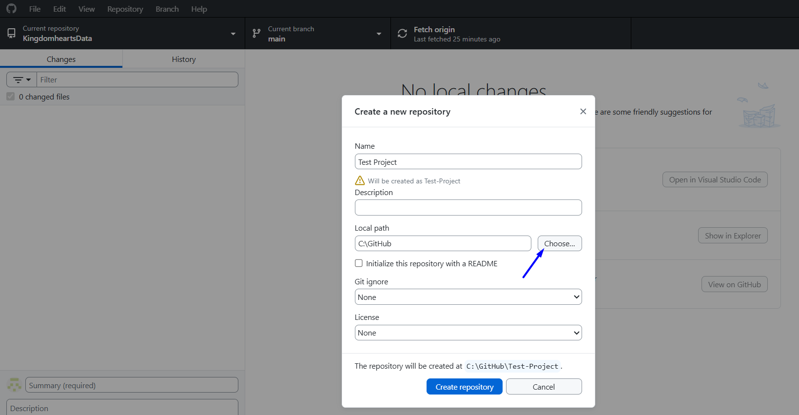
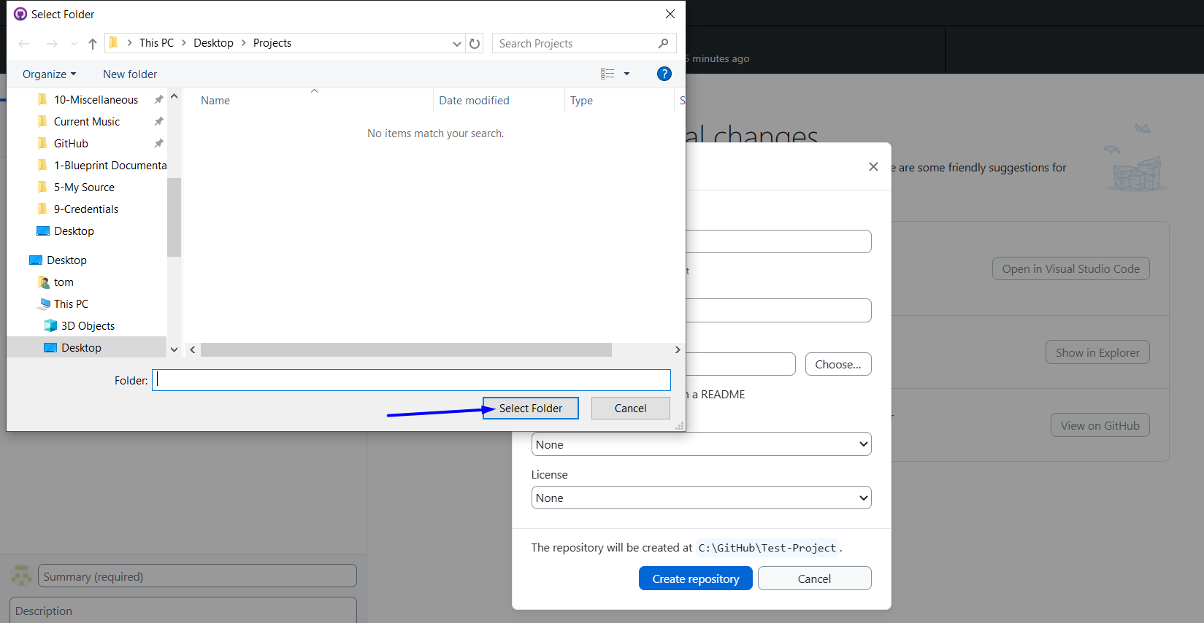

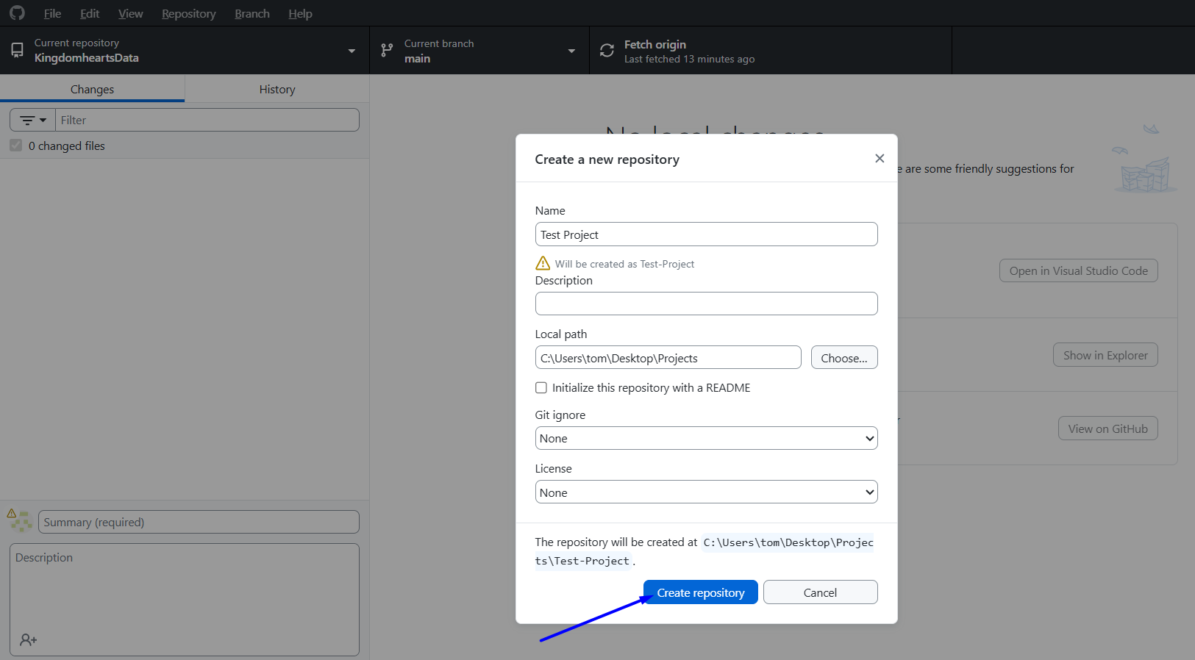
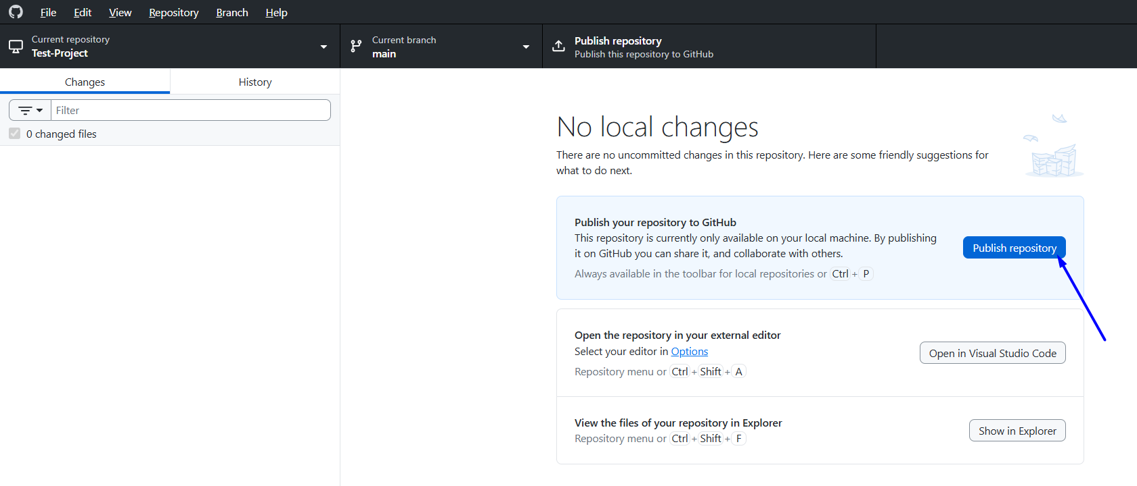
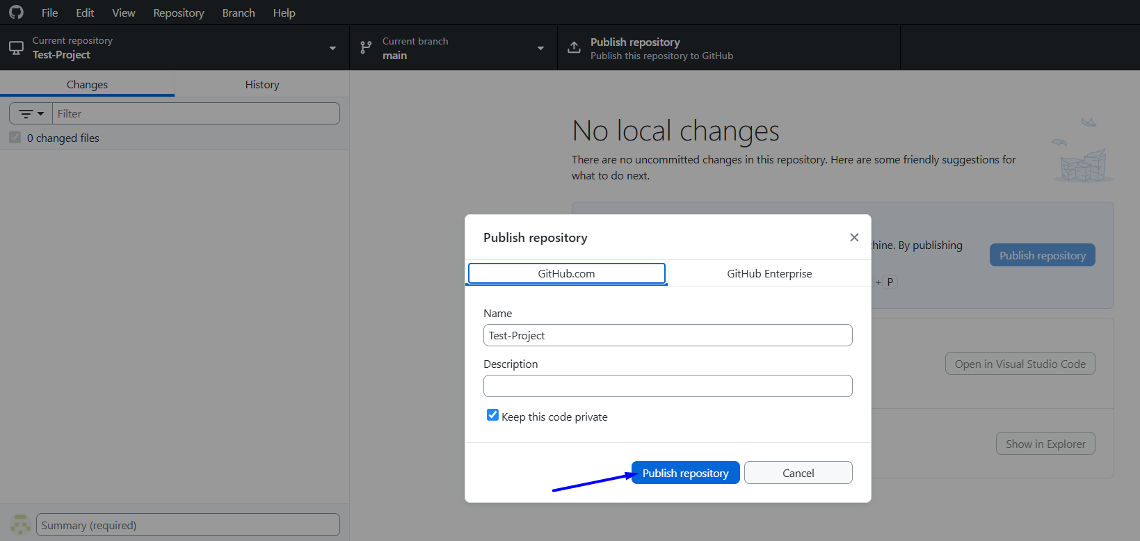
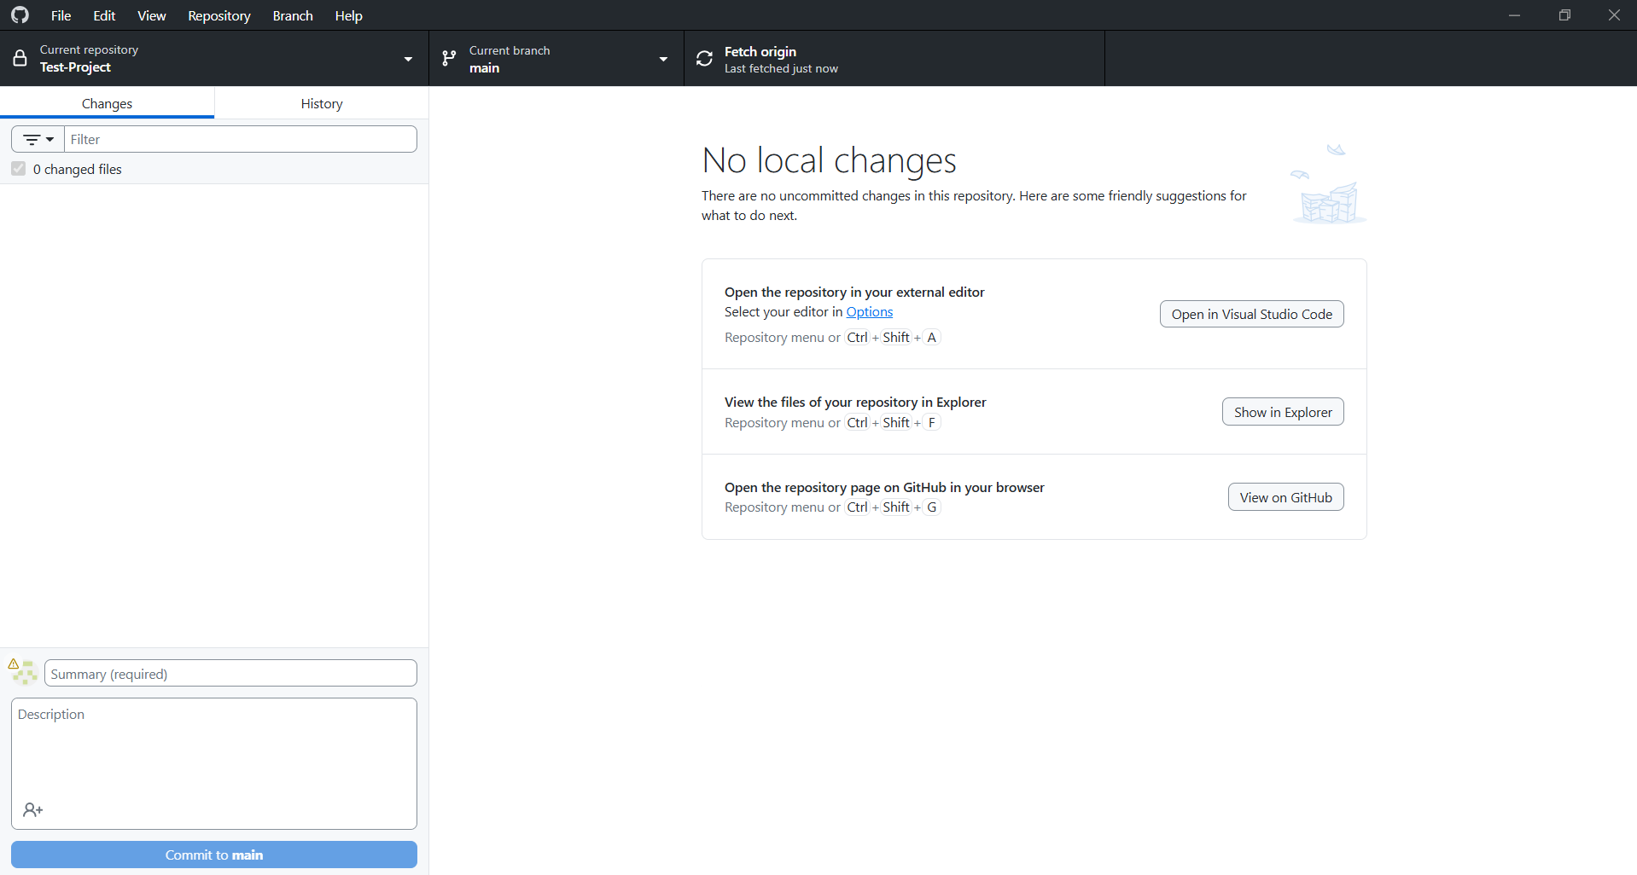
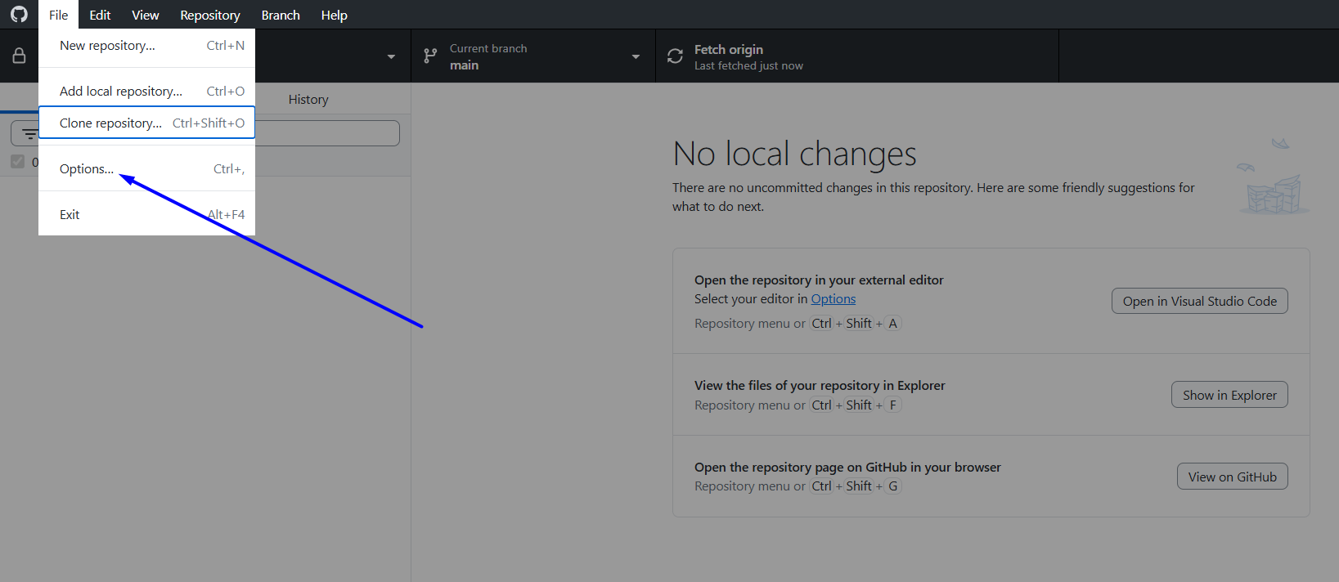
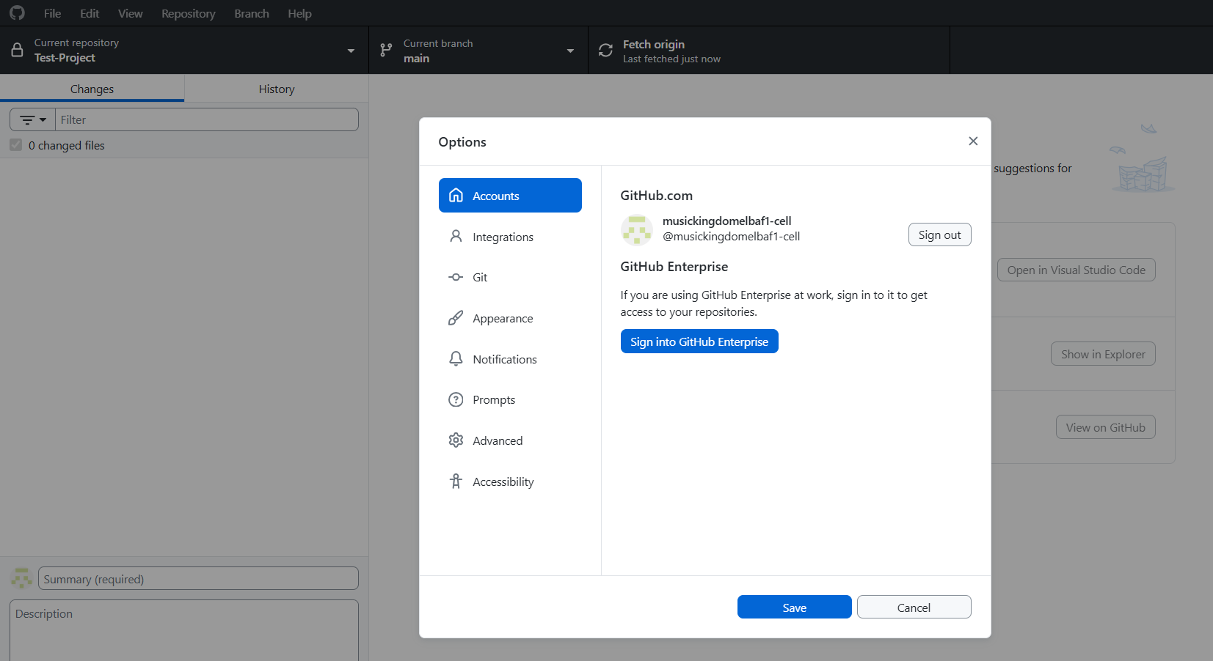

# Source: ScreenShots Source: Provided by: [Persons Table -> ID Column: 1, Name_En Column: Motasem Essam] -> Tool: [Lightshot Program] -> From [Site: https://github.com/musickingdomelbaf1-cell/Test-Project] on [2/17/2026]
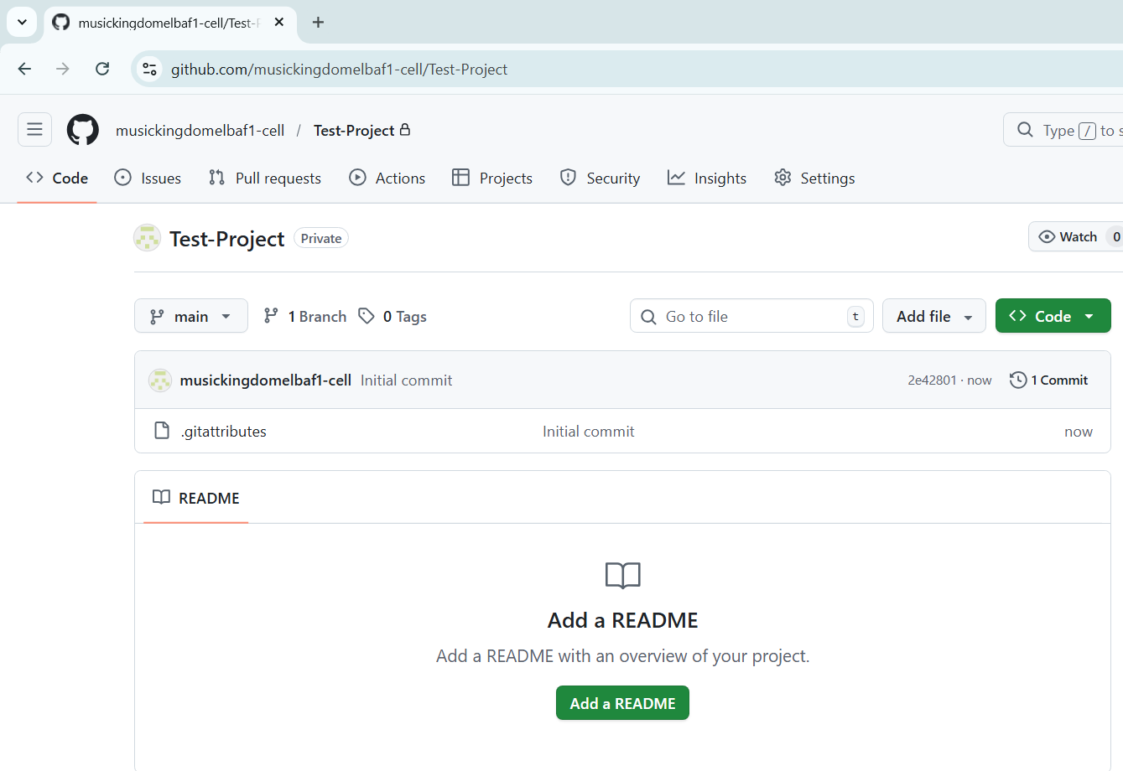

Add local repository
# Source: ScreenShots Source: Provided by: [Persons Table -> ID Column: 1, Name_En Column: Motasem Essam] -> Tool: [Lightshot Program] -> From [Windows] on [2/17/2026]
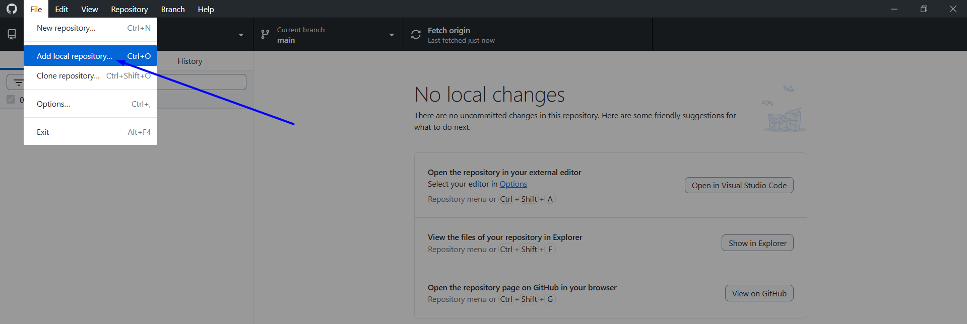
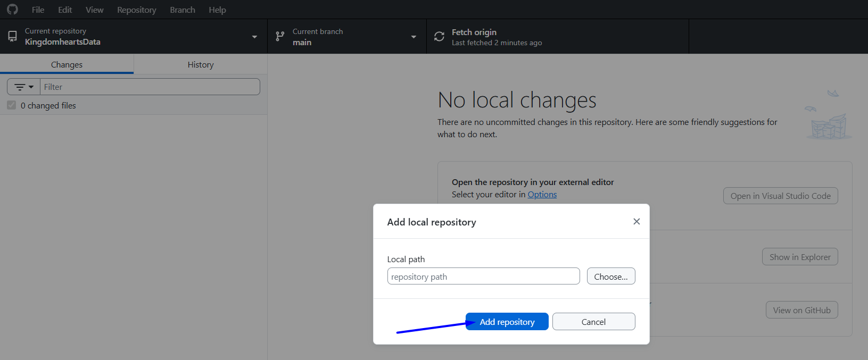

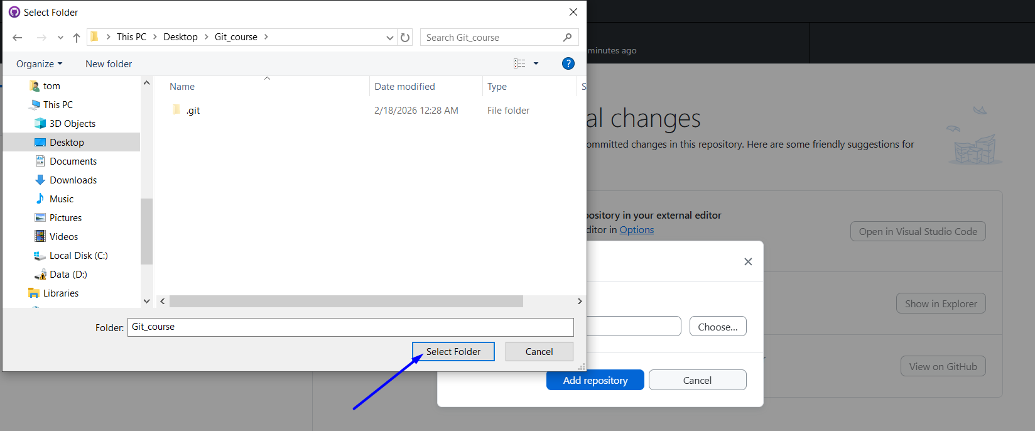
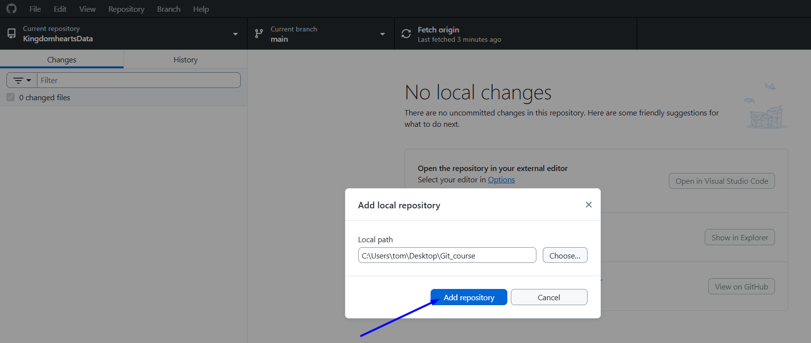

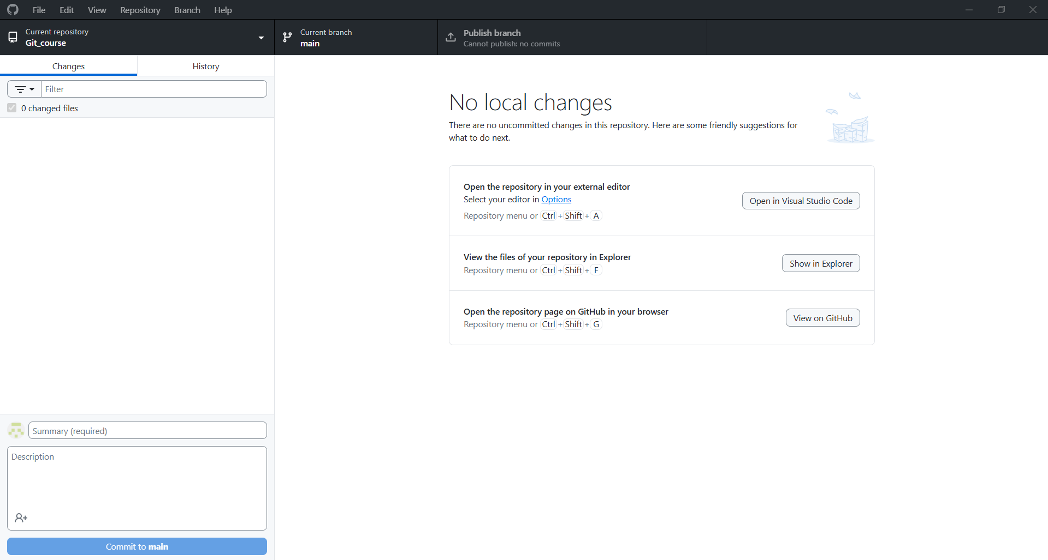

Clone repository
# Source: ScreenShots Source: Provided by: [Persons Table -> ID Column: 1, Name_En Column: Motasem Essam] -> Tool: [Lightshot Program] -> From [Windows] on [2/17/2026]
